What Happened to the UU Principles? The Move to UU Values.
At the General Assembly in June 2020, a study commission was formed to study Article 2 of the UUA bylaws for possible amendments or revisioning. The UUA bylaws is the document that lays out how our association of congregations covenant with each other on how to carry on the business of the association but more importantly, who we are in our purpose and ideals. Article 2 of those bylaws currently contains our principles and sources of wisdom, our statement of purpose, our statement of inclusion and our statement on Freedom of Belief.
The Study Commission re-visioned the entire Article 2 and presented their proposal at the General Assembly in June 2023. At that assembly, the congregational delegates voted overwhelmingly to continue the study for one more year to allow congregations to hold conversations around the proposed changes before the next General Assembly in June 2024. A Final Revised version (incorporating changes approved at the prior GA) was published in October 2023 and additional amendments that had 15+ congregations support had to be submitted by February 1, 2024.
What follows is a detailing of our current principles and the proposed UU Values and Covenant statements so that you can become familiar with what is proposed, process it, and think about what it would mean for our Faith, our Congregation, and you if the proposed Article 2 is adopted or not at the next General Assembly. The other portions of Article 2 are in a separate reading.
Our current Principles as stated in Article 2 of the UUA Bylaws:
We, the member congregations of the Unitarian Universalist Association, covenant to affirm and promote:
- The inherent worth and dignity of every person;
- Justice, equity and compassion in human relations;
- Acceptance of one another and encouragement to spiritual growth in our congregations;
- A free and responsible search for truth and meaning;
- The right of conscience and the use of the democratic process within our congregations and in society at large;
- The goal of world community with peace, liberty and justice for all;
- Respect for the interdependent web of all existence of which we are a part.

The Proposed Revisions to the Article 2 moves the Principles into Values and Covenants. There are 6 that were proposed by the commission and two more as amendments submitted by at least 15 certified congregations denoted by an *. At the General Assembly in June 2024, the amendments will be voted on by the delegates one at a time. If they are approved, they will be incorporated into the Proposed Revisions for Article 2 and then a final up or down vote for the entirety of the proposed Article 2 will be held.
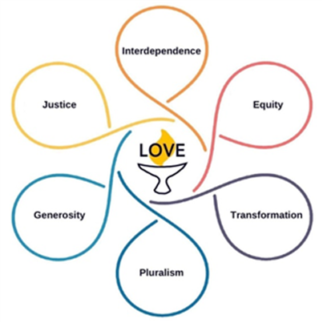
Note that the proposed UU Values each have a “tag line” defining that value followed by a covenant to an action related to that value.
Section C-2.2. Values and Covenant
As Unitarian Universalists, we covenant, congregation-to-congregation and through our Association, to support and assist one another in our ministries. We draw from our heritages of freedom, reason, hope, and courage, building on the foundation of love.
Love is the power that holds us together and is at the center of our shared values. We are accountable to one another for doing the work of living our shared values through the spiritual discipline of Love.
Inseparable from one another, these shared values are:
Interdependence: We honor the interdependent web of all existence. With reverence for the great web of life and with humility, we acknowledge our place in it.
We covenant to protect Earth and all beings from exploitation. We will create and nurture sustainable relationships of care and respect, mutuality and justice. We will work to repair harm and damaged relationships.
Pluralism : We celebrate that we are all sacred beings, diverse in culture, experience, and theology.
We covenant to learn from one another in our free and responsible search for truth and meaning. We embrace our differences and commonalities with Love, curiosity, and respect.
Justice: We work to be diverse multicultural Beloved Communities where all thrive.
We covenant to dismantle racism and all forms of systemic oppression. We support the use of inclusive democratic processes to make decisions within our congregations, our Association, and society at large.
Transformation: We adapt to the changing world.
We covenant to collectively transform and grow spiritually and ethically. Openness to change is fundamental to our Unitarian and Universalist heritages, never complete and never perfect.
Generosity: We cultivate a spirit of gratitude and hope.
We covenant to freely and compassionately share our faith, presence, and resources. Our generosity connects us to one another in relationships of interdependence and mutuality.
Equity: We declare that every person has the right to flourish with inherent dignity and worthiness.
We covenant to use our time, wisdom, attention, and money to build and sustain fully accessible and inclusive communities.
* Peace. We dedicate ourselves to peaceful conflict resolution at all levels.
We covenant to promote a peaceful world community with liberty and human rights for all. Whenever and wherever possible we will support nonviolent means to achieve peace.
* Reason. We search for truth and meaning, informed by reason, evidence, and the results of science, motivated by wonder, curiosity, and compassion.
We covenant to listen to and respect the views of others, and to remain open to new ideas.

